INFORMATION
on holding the XXIV Work Contests competition
"The most interesting Russian book or poem I have ever read"

For 24 years Exeter’s twin city in Russia, Yaroslavl, has been hosting an English language essay competition for students. For the first time this year they are opening the competition to students and young people in Exeter and Devon. This is an exciting opportunity for students to connect with people from another society and culture. It is also an excellent chance to build your research skills and have your work assessed by a panel of teachers in Russia. All participants will be awarded a diploma by the authorities in Russia, and the very best projects will receive prizes. If you have any questions about the contest please email: victoriafurtado@exe-coll.ac.uk

You need to register by 1 April 2021 then submit your completed project by 15 April 2021

- ORGANIZING BODIES
The competition is organized by the Yaroslavl City Public Organization "Yaroslavl-Exeter Friendship Society" and "Exeter-Yaroslavl Twinning Association “. The Organizing Committee (Chairperson T.A. Smirnova) are responsible for holding the contest.

- CONTEST PERIOD
February 15 - April 20, 2021. Results are announced in May 2021.

- CONDITIONS FOR THE IMPLEMENTATION OF THE CONTEST
  - Pupils of secondary and high schools, grammar schools and academies and students of colleges of Yaroslavl and the Yaroslavl Region, as well as British students from Exeter and the County of Devon are invited to participate.

  - Participants MUST submit an application to writingenglish@mail.ru by April 1, 2021, marked "Creative Competition"
The application must include:
- surname, first name of the participant,
- date of birth
- e-mail address
- name of school
- form of creative work you have chosen
- first name and surname of the supervising teacher

- In the project work it is recommended to present the information about your literary/reading interests/preferences, first reading impressions and the role of books in your life. The work may include descriptions and analysis of episodes, characteristics of characters from your favourite Russian book or poem, and problematic reflections on the role of the book or poem in today’s world. The work should not be purely informational in nature. It is desirable to reflect your own judgments, analysis and comparisons.

- The following forms of creative work are suggested:
- essay or composition;
- your original story, poem ( based on the book you have chosen)
- project work of social, informational, creative, and research nature;
- video (with accompanying printed material);
- computer presentation (with accompanying printed material);
- drawings, photographs, and reproductions which serve as illustrative material for the text;
- quizzes, crossword puzzles, booklets and collage on a given topic as an appendix to the work.

- Evaluation criteria:
- relevance to the theme;
- solution of communicative problem;
- presence of introduction, the main part, conclusion;
- originality and creative approach to the content and design;
- the implementation of the objectives and tasks of the project work,
- when creating a video or computer presentation an accompanying text is necessary;

- Requirements for the printed version of the work
- no more than 5 pages of the typed text (A4)
- format, Times New Roman, font 12, interval 1,5).
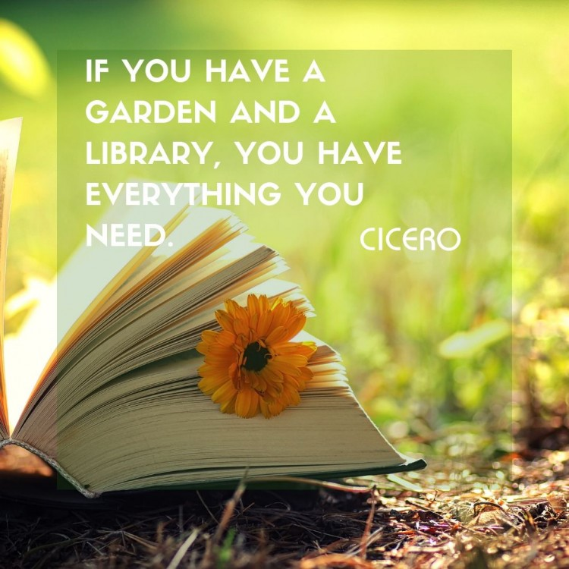
- The work must be written in English.
- A list of references must be attached to the work.
- All expenses for papers’ design are to be covered by the participants.
- Project works will be accepted in electronic form by April 20, 2021 (writingenglish@mail.ru)
- All participants will receive diplomas.
- The best works will be awarded with diplomas and prizes.

