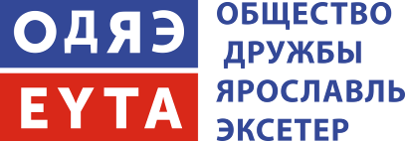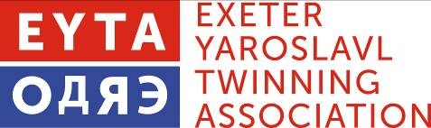

Peter Barker, 2 Oriole Drive, EXETER, EX4 4SJ Telephone 01392 495984 info@eyta.org.uk

Personal Details: Twinning Exchange to Yaroslavl
This information is required by «Общество Дружбы Ярославль - Эксетер» (Yaroslavl Exeter Friendship Society), who will use it to obtain your official invitation to Russia. You will need this to apply for your Russian visa.

Please complete it in Black Biro and Capital Letters. Then return it to me with photocopies of the ”Information” and “Official Observation” pages from your passport (i.e. pages with your photos) together with £25 non-returnable payment to cover administrative costs here and in Yaroslavl. Cheques should be made payable to EYTA. Alternatively, you can pay direct to our bank account;
Santander 09-01-55 35972083 Exeter Yaroslavl Twinning Association

We will forward this form and photocopies to Yaroslavl.
Please note: You must have 6 months validity remaining on your passport at the end of the visit.

FULL NAME …………………………………………………………………………………………………………………………………………
PREVIOUS SURNAMES…………………………………………………………………………………………………………………………
ADDRESS…………………………………………………………………………………………………………………………………………..……………………………………………………………………………………………………………………………………………………………………………………………………………………………………………………………………………………………………………………….……
POST CODE……………………………………………………………………………………………………………………………….…………
DATE OF BIRTH………………………………………………………………………………………………………………………….………..
PLACE OF BIRTH………………………………………………………………………………………………………………………….……….
SEX……………………………………………………………………..……………………………………………………………………………….
CITIZENSHIP…………………………………………………………………………………………………………………………………………COUNTRY OF RESIDENCE……………………………………………………………………………………………………………………..
OCCUPATION……………………………………………………………………………………………………………………………………….
PLACE OF WORK………………………………………………………………………………………………………………………………….
WORK ADDRESS…………………………………………………………………………………………………………………………………..
PASSPORT NUMBER ……………………………………………………………………………………………………………………………
DATE OF ISSUE…………………………………………………………………………………….………………………………………………
DATE OF EXPIRY…………………………………………………………………………………….…………………………………………….
Contact me if you have questions. Return the form and your passport photocopies and £25 to me

With regards

Peter Barker

