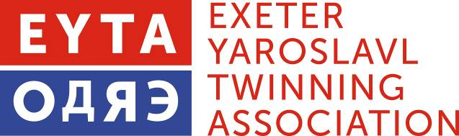

Membership Renewal Form 2020 - 2021

NAME(S):….………………………………………………………………………………….

ADDRESS: ………………………………………………………………………………………………………….

……………………………………………………………………………………………………………

POSTCODE: ………………………………………………… TEL ……………….…………………

E-MAIL: ………………………………………………………………………………………………

Any other Information: e.g. special interests, or projects and activities that would interest you etc.

………………………………....…………………………………………………………………………

……………………………………………………………………………………………………………

……………………………………………………………………………………………………………

I enclose £ ........... my/our EYTA Annual Subscription

£6 Individual, £9 Couple, £20 Organisations, Students Free.

Additional donations are always gratefully received

If you would like to pay by Standing Order or direct bank payment our account details are:

Santander 09-01-55 35972083 Exeter Yaroslavl Twinning Association

Otherwise please make cheques payable to EYTA and send with this slip to:

Peter Barker, 2 Oriole Drive, EXETER, EX4 4SJ
email: info@eyta.org.uk

We share member’s contact details within the Association. If you wish yours to be withheld please tell us.

